**Assignment 8**

**Implement Lamport’s clock synchronization algorithm and discuss its time complexity.**

**Input:**

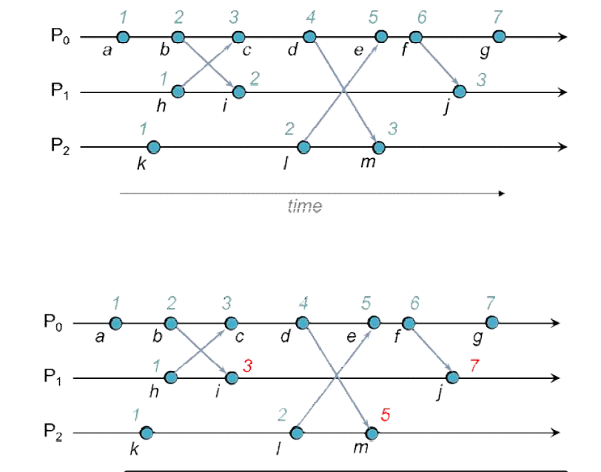

**Code:**

